# Quinte Financial Technologies | FinTech Solutions

**Assignment on**

**BLOCKCHAIN, CYBERSECURITY MEASURES AND**

**BIOMETRIC AUTHENTICATION SYSTEM IN BANKING**

**Under Supervision of:**

**Mr. Mohammad Mozammil**

**Given On:**

**8th July, 2024**

**Submitted By:**

**Archita Gupta**

Table of Contents

Blockchain in Banking 4

Cybersecurity Measures 7

Biometric Authentication System 11

# Blockchain in Banking

Blockchain technology is a decentralized, distributed ledger system that allows for secure and transparent transactions between two parties without the need for a trusted intermediary. The ledger consists of a series of interconnected blocks, each containing a list of transactions. Once a block is added to the chain, it cannot be altered, making it tamper-proof. The blockchain also uses cryptography to ensure that only authorized parties can access and validate transactions.

This technology has the potential to revolutionize the way banks in following ways:

* **Slow and Expensive Transactions:** Cross-border transactions and settlements can take several days and incur high fees due to multiple intermediaries.
* **Fraud and Security Risk:** Banks are vulnerable to fraud, cyber-attacks, and data breaches.
* **Lack of Transparency:** Traditional banking systems can lack transparency, leading to issues with trust and accountability.
* **Inefficiencies in Clearing and Settlement:** The clearing and settlement of transactions can be slow and complex, involving multiple intermediaries and processes.
* **KYC and AML Compliance:** Know Your Customer (KYC) and Anti-Money Laundering (AML) compliance processes are time-consuming and costly.
* **Limited Financial Inclusion:** Many people, especially in developing regions, lack access to banking services.
* **Lack of Interoperability:** Traditional financial systems often struggle with interoperability, making it difficult to integrate different systems and processes.
* **High Operational Costs:** Banks face high operational costs due to the need for physical infrastructure, intermediaries, and complex processes.
* **Challenges in Trade Finance:** Trade finance involves multiple parties and complex documentation, leading to inefficiencies and delays.
* **Asset Management and Tokenization:** Traditional asset management can be cumbersome and lacks liquidity.
* **Risk Management and Auditing:** Risk management and auditing are often complex and time-consuming.

**Advantages of Blockchain in Banking:**

**1. Cost Reduction**

* **Eliminates inefficiencies**: Streamlines processes, reducing reliance on intermediaries.
* **Significant savings**: Potential to save billions in operations like clearing and settlement.

**2. Robust Security**

* **Enhanced KYC solutions**: Cryptographic protection verifies identities securely.
* **Reduces data breaches**: Decentralization eliminates single points of failure.
* **Smart contracts**: Automatic, secure transactions without intermediaries.

**3. Instant Payments and Money Transfers**

* **Direct connections**: Banks can connect directly, bypassing intermediaries like SWIFT.
* **Faster cross-border transactions**: Near-instantaneous processing improves efficiency.

**4. Digital Currency**

* **Asset digitization**: Blockchain supports a variety of digital currencies.
* **Central Bank Digital Currencies (CBDCs)**: Examples include China's DC/EP and JPMorgan’s JPM Coin.

**5. Reduced Error**

* 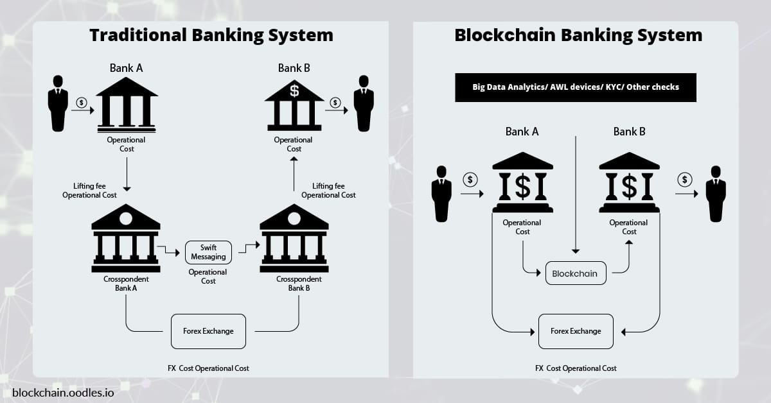**Smart contracts**: Automate transactions, minimizing human error and reducing the need for trust.

Real-World Examples:

* **J.P. Morgan:** Uses Quorum blockchain for interbank payments and compliance reporting.
* **Swedish Central Bank:** Experimenting with e-krona, a CBDC.
* **HSBC:** Implemented blockchain-based trade finance platform to digitize and streamline operations.

**Challenges of Blockchain Adoption**

* **Regulatory Compliance:** Complex and evolving legal requirements.
* **Data Privacy:** Transparency raises privacy concerns.
* **Technological Hurdles:** Scalability, interoperability, and integration with legacy systems.

# Cybersecurity Measures

The banking sector is a prime target for cyber-attacks due to the sensitive financial data and assets it handles. Implementing robust cybersecurity measures is critical to protect against threats and ensure the integrity of financial systems.

**Rising Cyber Threats**

* **Significant Increase in Attacks:** Financial institutions are heavily targeted, with 566 breaches in 2022 leaking over 254 million records.
* **Ransomware Surge:** Attacks rose from 55% in 2022 to 64% in 2023, with 81% of attacks resulting in data encryption.
* **Cost of Breaches:** Average data breach cost in the finance sector is $5.9 million.

**Types of Threats**

* **Ransomware-as-a-Service (RaaS):** Threat actors license ransomware tools, increasing the sophistication and frequency of attacks.
* **Distributed Denial of Service (DDoS):** Overwhelms systems with traffic, disrupting operations and services.

**Consequences of Cyber Attacks**

* **Immediate Costs:** Ransom payments, forensic analysis, crisis management, legal expenses, and customer compensation.
* **Regulatory and Legal Consequences:** Fines for non-compliance with data protection regulations and potential lawsuits.
* **Operational Disruptions:** Services delays, transaction lock-ups, and reputational damage affecting customer trust and market position.

**Building Cyber Resilience**

1. **Response & Recovery**
   * Develop and regularly update incident response plans.
   * Maintain relationships with law enforcement and cyber forensics experts.
   * Conduct regular recovery exercises and consider cyber insurance.
2. **Network & System Security**
   * Adopt an "assume breach" mentality for proactive threat detection.
   * Secure network components, perform vulnerability scans, and adhere to patch management schedules.
   * Add threat detection for email systems and segment critical network components.
3. **Identity & Access Management**
   * Implement multi-factor authentication (MFA) and role-based access control (RBAC).
   * Apply the Principle of Least Privilege (PoLP) and conduct regular account audits.
   * Use strong encryption protocols for secure authentication.

**Key Measures:**

**1. Encryption**

* **Data Protection:** Encrypting sensitive data both in transit and at rest ensures that it cannot be easily intercepted or accessed by unauthorized parties.
* **Secure Communication:** Using protocols like SSL/TLS for secure communications over the internet.

**2. Multi-Factor Authentication (MFA)**

* **Enhanced Security:** Requires users to provide two or more verification factors to gain access, reducing the risk of compromised credentials.
* **Types of MFA:** Can include something the user knows (password), something the user has (smartphone), and something the user is (biometrics).

**3. Regular Security Audits and Assessments**

* **Vulnerability Assessment:** Regularly identifying and addressing vulnerabilities in the system.
* **Penetration Testing:** Simulating cyber-attacks to test the strength of security measures.

**4. Firewalls and Intrusion Detection/Prevention Systems (IDS/IPS)**

* **Network Security:** Firewalls monitor and control incoming and outgoing network traffic based on predetermined security rules.
* **Threat Detection:** IDS/IPS systems detect and prevent potential threats in real-time.

**5. Employee Training and Awareness**

* **Security Awareness Programs:** Regular training sessions for employees on the latest cybersecurity threats and best practices.
* **Phishing Simulations:** Conducting mock phishing attacks to educate employees on identifying and avoiding phishing scams.

**6. Access Controls and Identity Management**

* **Role-Based Access Control (RBAC):** Restricting access to systems and data based on the user's role within the organization.
* **Identity Management Solutions:** Ensuring that only authorized individuals have access to sensitive systems and data.

**7. Data Backup and Recovery**

* **Regular Backups:** Ensuring that data is regularly backed up to prevent loss in case of a cyber-attack.
* **Disaster Recovery Plans:** Developing and regularly testing plans to quickly recover data and systems after an incident.

**8. Anti-Malware and Anti-Virus Software**

* **Malware Protection:** Installing and regularly updating anti-malware and anti-virus software to protect against malicious software.
* **Regular Scans:** Conducting regular scans to detect and remove any malware present in the system.

**9. Secure Software Development Practices**

* **Secure Coding:** Following secure coding practices to minimize vulnerabilities in software applications.
* **Code Reviews:** Conducting regular code reviews and static analysis to identify and fix security issues.

**10. Incident Response Planning**

* **Preparation:** Developing a comprehensive incident response plan to quickly address and mitigate the impact of security incidents.
* **Incident Handling:** Establishing clear procedures for detecting, responding to, and recovering from security incidents.

**11. Monitoring and Logging**

* **Continuous Monitoring:** Implementing systems for continuous monitoring of network and system activities to detect suspicious behavior.
* **Log Management:** Collecting and analyzing logs to identify potential security incidents and for post-incident analysis.

**12. Compliance with Regulatory Standards**

* **Regulatory Requirements:** Ensuring compliance with relevant regulatory standards such as GDPR, PCI-DSS, and others specific to the banking sector.
* **Regular Audits:** Conducting regular compliance audits to ensure adherence to regulatory requirements.

# Biometric Authentication System

Biometric authentication refers to a cybersecurity process that verifies a user’s identity using their unique biological traits such as fingerprints, voices, retinas, and facial features. Biometric authentication systems store this information in order to verify a user’s identity when that user accesses their account. This type of authentication is usually more secure than traditional forms of multi-factor authentication as they use unique biological traits to verify an individual's identity. These systems are increasingly being adopted due to their enhanced security features and user convenience.

**Types of Biometric Systems**

1. **Fingerprint Recognition:**
   * Uses patterns of ridges and valleys on a finger.
   * Common in smartphones and access control systems.
2. **Facial Recognition:**
   * Analyzes facial features such as the distance between eyes, nose width, and jawline shape.
   * Used in security systems, smartphones, and social media tagging.
3. **Iris Recognition:**
   * Scans the unique patterns in the colored ring of the eye.
   * Employed in high-security environments like airports.
4. **Voice Recognition:**
   * Identifies individuals based on vocal attributes.
   * Used in customer service and call center verification.
5. **DNA Matching:**
   * Compares genetic material.
   * Primarily used in forensic science.

**Advantages and Disadvantages in baking sector:**

**Pros:**

1. **Enhanced Security:** Biometrics provide a higher level of security compared to traditional methods like passwords or PINs, as they are unique to each individual and difficult to replicate.
2. **Convenience:** Users don't need to remember passwords or carry physical tokens, improving user experience and reducing friction during transactions.
3. **Non-Transferable:** Biometric traits such as fingerprints or iris patterns cannot be easily transferred or stolen, reducing the risk of unauthorized access.
4. **Reduced Fraud:** Biometric authentication helps in reducing instances of identity theft and fraud, as it ensures that only authorized individuals can access accounts or perform transactions.
5. **Compliance:** Helps banks meet regulatory requirements related to security and customer authentication, such as GDPR in Europe or PCI-DSS standards.

**Cons:**

1. **Privacy Concerns:** Biometric data, if compromised, can lead to serious privacy issues. Storage and handling of biometric information require robust security measures to prevent unauthorized access.
2. **Accuracy and Reliability:** Biometric systems may face challenges with accuracy due to variations in biometric traits (e.g., changes in fingerprint due to injury) or environmental factors (e.g., poor lighting affecting facial recognition).
3. **Costs:** Implementing biometric systems can be expensive, involving initial setup costs, maintenance, and integration with existing banking infrastructure.
4. **Integration Challenges:** Introducing biometric authentication into existing banking systems can be complex and may require significant changes to IT infrastructure and processes.
5. **User Acceptance:** Some users may be hesitant to adopt biometric authentication due to concerns about unfamiliarity and unreliability of the technology.

**Challenges:**

1. **Security of Biometric Data:** Protecting biometric data from theft or misuse is crucial. Banks must implement strong encryption and secure storage methods to safeguard biometric templates.
2. **Regulatory Compliance:** Meeting regulatory requirements for handling sensitive biometric information, such as data protection laws (e.g., GDPR) and financial industry regulations (e.g., PCI-DSS).
3. **Technological Adaptation:** Ensuring biometric systems are compatible with diverse banking platforms and devices, including mobile banking apps and ATMs.
4. **Interoperability:** Biometric systems need to work seamlessly across different banking channels and with third-party services, requiring standardization and interoperability protocols.

**Applications in Banking Sector:**

1. **Customer Authentication:** Secure login to mobile banking apps or online banking platforms using fingerprints, facial recognition, or voice biometrics.
2. **Transaction Authorization:** Confirming high-value transactions or transfers through biometric authentication to prevent fraud and unauthorized access.
3. **ATM Security:** Biometric ATMs that authenticate users using fingerprints or iris scans for secure cash withdrawals and other transactions.
4. **Fraud Prevention:** Detecting and preventing fraudulent activities by verifying the identity of customers in real-time using biometric authentication.

**Future Trends:**

1. **Multi-modal Biometrics:** Combining multiple biometric traits (e.g., fingerprint and facial recognition) for stronger authentication and improved accuracy.
2. **Mobile Integration:** Increasing use of biometric authentication in mobile banking apps and wearable devices for seamless and secure customer experiences.
3. **AI and Machine Learning:** Integration of AI and machine learning algorithms to enhance biometric system capabilities, such as adaptive authentication and behavioral biometrics.
4. **Blockchain Integration:** Using blockchain technology to securely store and manage biometric data, ensuring transparency and immutability.
5. **Continuous Authentication:** Implementing continuous authentication methods that monitor user behavior and biometric patterns throughout the banking session for enhanced security.

Thank You